- Configuring Extended ACLs a. Configure, Apply and Verify an Extended Numbered ACL.

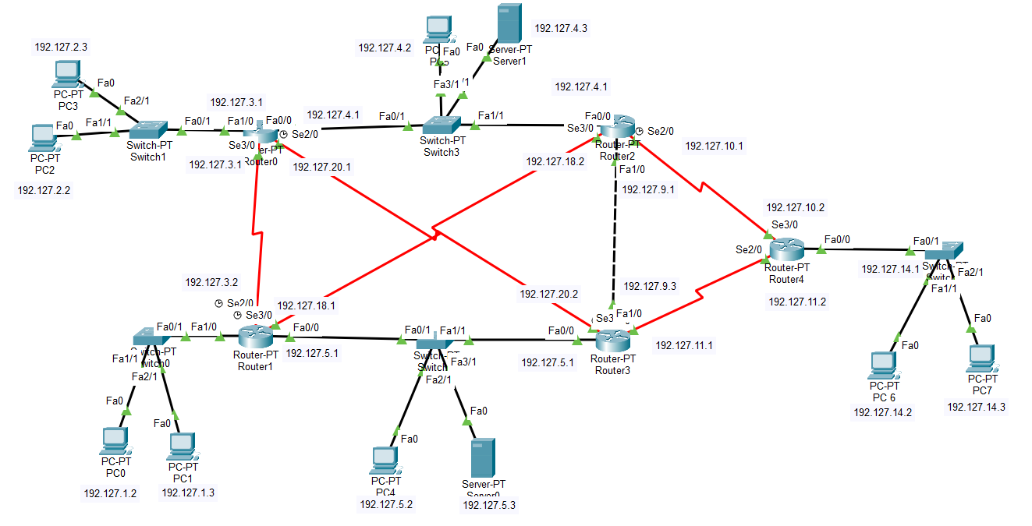

- Telnet :
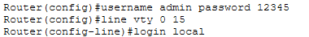

Accessing the router 1 through PC2 :
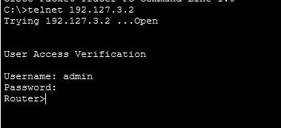

- SSH:-
To define SSH we will execute following commands on Routers.
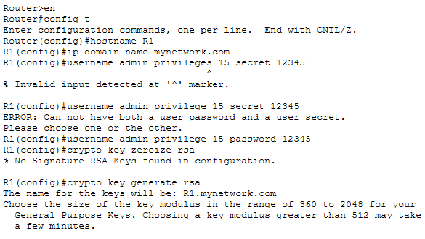
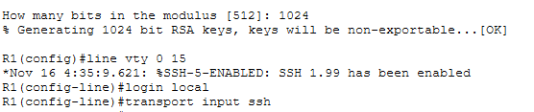

Since as above we Already start SSH we will now try to access it through pc.
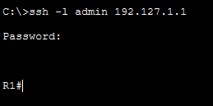

- Extended Numbered ACL.
Configure access to router IP 192.127.2.3
- Router R1 should only be accessible from other than network 192.127.1.0
- Allow SSH(port 22) traffic from IPs 192.127.1.0 , 192.127.3.2 , 192.127.18.1 , 192.127.5.1 going to the device 192.127.2.3 . Host is used to defined single device.
- Then you have to defined it as below as to all interfaces which are between them:-
- access-list 100 permit tcp 192.127.2.3 host 192.127.1.2 eq 22

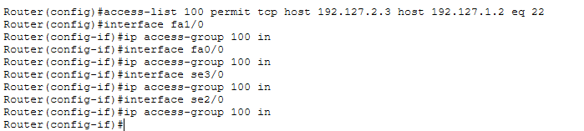

You can defined all ips as follow:-
Now to define for particular host we can defined as follow:-
- access-list 100 deny tcp host 192.127.2.3 host 192.127.1.0 eq 22
- access-list 100 deny tcp host 192.127.2.3 host 192.127.3.2 eq 22
- access-list 100 deny tcp host 192.127.2.3 host 192.127.18.1 eq 22
- access-list 100 deny tcp host 192.127.2.3 host 192.127.5.1 eq 22

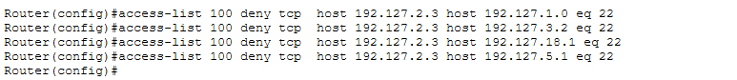

Accessing SSH router1 with PC :

Now we can try to check whether the ssh is allow right now or not from that ip as follow:-
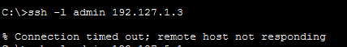

Accessing SSH router3 with PC :
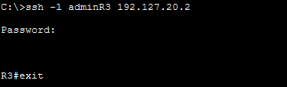

Now we can try to check whether the ssh is allow right now or not from that ip as follow:-
